HORN & LAURETTI
225 FRIEND STREET, SUITE 204

BOSTON, MA 02114
(617) 589-3000

FAX (617) 523-3812
JOHN M. HORN DENISE M. LAURETTI*
MICHAEL S. KINSON* JEFFREY D. SWARTZ

*Admitted in MA and NH

Peter T. Toland, Esquire
LaRosa/Toland Law Offices
3 Baldwin Green Common Suite 207
Woburn, MA 01801

RE: Frost v. Criscuolo, et al
Middlesex County Middlesex Superior Court Division Civil Action No.: 08-4065

Dear Attorney Toland:

Attached pursuant to Rule 30 and Rule 45 of the Massachusetts Rules of Civil Procedure, is a copy of the Keeper of Records Notice of Taking Deposition and Subpoena for the following locations and relating to the above-captioned matter:

Fallon Community Health Plan (Insurance Records)

In accordance with the requirements of the Health Insurance Portability and Accountability Act (“HIPAA”) Privacy Standards, please notify your client that these records are being sought. In addition, please notify your client that he/she and you have ten days from the date of this letter to raise objections to any subpoena for medical records in the court in which we have brought the proceeding. If, after ten days, I have received no notification from you that any objection has been raised, I will assume that there is no objection to this request for information, and will so notify the Keeper of Records for the above-named provider.

Thank you for your attention to this matter.

Very truly yours,
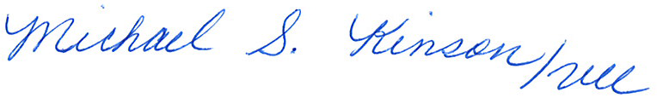

John M. Horn

MSK/vll
Enclosure
Cc: John M. Horn and William Morley

Order No. 01-17231-010

Staff Counsel: Hanover Insurance Company/Citizens Insurance Company
Not a Partnership

